**Anirudh Srinivaas -2015103052**

**M.R. Narayanan - 2015103040**

**DBMS**

Question 1

|  |
| --- |
|  |

Consider the following relational schema.

Students(rollno: integer, sname: string)

Courses(courseno: integer, cname: string)

Registration(rollno: integer, courseno: integer, percent: real)

Which of the following queries are equivalent to this query in English?

"Find the distinct names of all students who score

more than 90% in the course numbered 107"

[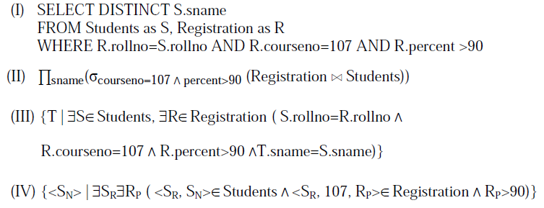](http://www.geeksforgeeks.org/wp-content/uploads/gq/2013/10/gatecs201314.png)

|  |  |
| --- | --- |
| A | I, II, III and IV |
| B | I, II and III only |
| C | I, II and IV only |
| D | II, III and IV only |

|  |
| --- |
| **Question 2** |

Given the basic ER and relational models, which of the following is INCORRECT?

|  |  |
| --- | --- |
| A | An attribute of an entity can have more than one value |
| B | An attribute of an entity can be composite |
| C | In a row of a relational table, an attribute can have more than one value |
| D | In a row of a relational table, an attribute can have exactly one value or a NULL value |

|  |
| --- |
| **Question 3** |

Suppose (A, B) and (C,D) are two relation schemas. Let r1 and r2 be the corresponding relation instances. B is a foreign key that refers to C in r2. If data in r1 and r2 satisfy referential integrity constraints, which of the following is ALWAYS TRUE?

[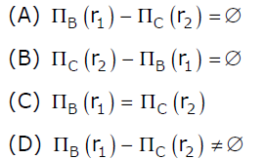](http://www.geeksforgeeks.org/wp-content/uploads/gq/2013/11/DBMSGATE2012.png)

|  |  |
| --- | --- |
| A | A |
| B | B |
| C | C |
| D | D |

|  |
| --- |
| **Question 4** |

Consider the following relations A, B, C. How many tuples does the result of the following relational algebra expression contain? Assume that the schema of A U B is the same as that of A.

[http://www.geeksforgeeks.org/wp-content/uploads/DBMSGATE20124-300x47.png](http://www.geeksforgeeks.org/wp-content/uploads/DBMSGATE20124.png)

**Table A**

Id Name Age

----------------

12 Arun 60

15 Shreya 24

99 Rohit 11

**Table B**

Id Name Age

----------------

15 Shreya 24

25 Hari 40

98 Rohit 20

99 Rohit 11

**Table C**

Id Phone Area

-----------------

10 2200 02

99 2100 01

|  |  |
| --- | --- |
| A | 7 |
| B | 4 |
| C | 5 |
| D | 9 |

|  |
| --- |
| **Question 5** |

Consider a relational table r with sufficient number of records, having attributes A1, A2,…, An and let 1 <= p <= n. Two queries Q1 and Q2 are given below.

[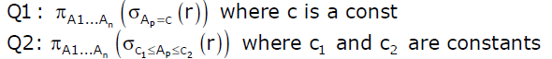](http://www.geeksforgeeks.org/wp-content/uploads/gq/2013/12/GATE2011DBMS1.png) The database can be configured to do ordered indexing on Ap or hashing on Ap. Which of the following statements is TRUE?

|  |  |
| --- | --- |
| A | Ordered indexing will always outperform hashing for both queries |
| B | Hashing will always outperform ordered indexing for both queries |
| C | Hashing will outperform ordered indexing on Q1, but not on Q2 |
| D | Hashing will outperform ordered indexing on Q2, but not on Q1. |

|  |
| --- |
| **Question 6** |

Which of the following tuple relational calculus expression(s) is/are equivalent to [18](http://www.geeksforgeeks.org/wp-content/uploads/gq/2014/01/18.gif)

[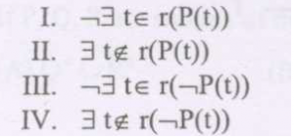](http://www.geeksforgeeks.org/wp-content/uploads/gq/2014/01/cs2008.png)

|  |  |
| --- | --- |
| A | I only |
| B | II only |
| C | III only |
| D | III and IV only |

|  |
| --- |
| **Question 7** |

1) Let R and S be two relations with the following schema R (P,Q,R1,R2,R3) S (P,Q,S1,S2) Where {P, Q} is the key for both schemas. Which of the following queries are equivalent?

[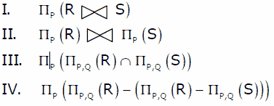](http://www.geeksforgeeks.org/wp-content/uploads/GATE2008DBMS1.gif)

|  |  |
| --- | --- |
| A | Only I and II |
| B | Only I and III |
| C | Only I, II and III |
| D | Only I, III and IV |

|  |
| --- |
| **Question 8** |

Consider the following ER diagram.[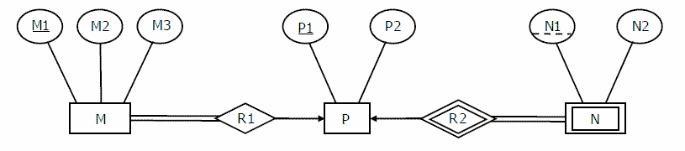](http://www.geeksforgeeks.org/wp-content/uploads/GATE2008DBMS_ERDIA.gif) The minimum number of tables needed to represent M, N, P, R1, R2 is

|  |  |
| --- | --- |
| A | 2 |
| B | 3 |
| C | 4 |
| D | 5 |

|  |
| --- |
| **Question 9** |

Consider the data given in above question. Which of the following is a correct attribute set for one of the tables for the correct answer to the above question?

|  |  |
| --- | --- |
| A | {M1, M2, M3, P1} |
| B | {M1, P1, N1, N2} |
| C | {M1, P1, N1} |
| D | {M1, P1} |

|  |
| --- |
| **Question 10** |

Information about a collection of students is given by the relation *studinfo(studId, name, sex)*. The relation *enroll(studId, courseId)* gives which student has enrolled for (or taken) that course(s). Assume that every course is taken by at least one male and at least one female student. What does the following relational algebra expression represent?[http://www.geeksforgeeks.org/wp-content/uploads/GATE2009DBMS12.gif](http://www.geeksforgeeks.org/wp-content/uploads/GATE2009DBMS12.gif)

|  |  |
| --- | --- |
| A | Courses in which all the female students are enrolled. |
| B | Courses in which a proper subset of female students are enrolled. |
| C | Courses in which only male students are enrolled. |
| D | None of the above |

|  |
| --- |
| **Question 11** |

In a relational database model, NULL values can be used for all but which one of the following ?

|  |  |
| --- | --- |
| A | To allow duplicate tuples in the table by filling the primary key column(s) with NULL. |
| B | To avoid confusion with actual legitimate data values like 0 (zero) for integer columns and ’’ (the empty string) for string columns. |
| C | To leave columns in a tuple marked as ’’unknown’’ when the actual value is unknown. |
| D | To fill a column in a tuple when that column does not really ”exist” for that particular tuple. |

|  |
| --- |
| **Question 12** |

Consider the following two commands C1 and C2 on the relation R from an SQL database: C1 : drop table R; C2 : delete from R; Which of the following statements is TRUE ? I. Both C1 and C2 delete the schema for R. II. C2 retains relation R, but deletes all tuples in R. III. C1 deletes not only all tuples of R, but also the schema for R.

|  |  |
| --- | --- |
| A | I only |
| B | I and II only |
| C | II and III only |
| D | I, II and III |

|  |
| --- |
| **Question 13** |

Consider the following database table having A, B, C and D as its four attributes and four possible candidate keys (I, II, III and IV) for this table : 20 I : {B} II : {B, C} III : {A, D} IV : {C, D} If different symbols stand for different values in the table (e.g., d1 is definitely not equal to d2), then which of the above could not be the candidate key for the database table ?

|  |  |
| --- | --- |
| A | I and III only |
| B | III and IV only |
| C | II only |
| D | I only |

|  |
| --- |
| **Question 14** |

A relation R = {A, B, C, D, E, F,G} is given with following set of functional dependencies: F = {AD → E, BE → F, B → C, AF → G} Which of the following is a candidate key ?

|  |  |
| --- | --- |
| A | A |
| B | AB |
| C | ABC |
| D | ABD |

|  |
| --- |
| **Question 15** |

Drop Table cannot be used to drop a Table referenced by __________ constraint. (a)Primary key (b)Sub key (c)Super key (d)Foreign key

|  |  |
| --- | --- |
| A | (a) |
| B | (a), (b) and (c) |
| C | (d) |
| D | (a) and (d) |

|  |
| --- |
| **Question 16** |

For a weak entity set to be meaningful, it must be associated with another entity set in combination with some of their attribute values, is called as:

|  |  |
| --- | --- |
| A | Neighbour Set |
| B | Strong Entity Set |
| C | Owner Entity Set |
| D | Weak Set |

|  |
| --- |
| **Question 17** |

Which of the following statements is FALSE about weak entity set?

|  |  |
| --- | --- |
| A | Weak entities can be deleted automatically when their strong entity is deleted. |
| B | Weak entity set avoids the data duplication and consequent possible inconsistencies caused by duplicating the key of the strong entity. |
| C | A weak entity set has no primary keys unless attributes of the strong entity set on which it depends are included |
| D | Tuples in a weak entity set are not partitioned according to their relationship with tuples in a strong entity set. |

|  |
| --- |
| **Question 18** |

In functional dependency Armstrong inference rules refers to

|  |  |
| --- | --- |
| A | Reflexive, Augmentation and Decomposition |
| B | Transitive, Augmentation and Reflexive |
| C | Augmentation, Transitive, Reflexive and Decomposition |
| D | Reflexive, Transitive and Decomposition |

|  |
| --- |
| **Question 19** |

The 'command' used to change contents of one database using the contents of another database by linking them on a common key field?

|  |  |
| --- | --- |
| A | Replace |
| B | Join |
| C | Change |
| D | Update |

|  |
| --- |
| **Question 20** |

The join operation can be defined as

|  |  |
| --- | --- |
| A | a cartesian product of two relations followed by a selection |
| B | a cartesian product of two relations |
| C | a union of two relations followed by cartesian product of the two relations |
| D | a union of two relations |

OS

|  |
| --- |
| **Question 1** |

Which of the following page replacement algorithms suffers from Belady’s anomaly?

|  |  |
| --- | --- |
| A | FIFO |
| B | LRU |
| C | Optimal Page Replacement |
| D | Both LRU and FIFO |

|  |
| --- |
| **Question 2** |

What is the swap space in the disk used for?

|  |  |
| --- | --- |
| A | Saving temporary html pages |
| B | Saving process data |
| C | Storing the super-block |
| D | Storing device drivers |

|  |
| --- |
| **Question 3** |

Increasing the RAM of a computer typically improves performance because:

|  |  |
| --- | --- |
| A | Virtual memory increases |
| B | Larger RAMs are faster |
| C | Fewer page faults occur |
| D | Fewer segmentation faults occur |

|  |
| --- |
| **Question 4** |

A computer system supports 32-bit virtual addresses as well as 32-bit physical addresses. Since the virtual address space is of the same size as the physical address space, the operating system designers decide to get rid of the virtual memory entirely. Which one of the following is true?

|  |  |
| --- | --- |
| A | Efficient implementation of multi-user support is no longer possible |
| B | The processor cache organization can be made more efficient now |
| C | Hardware support for memory management is no longer needed |
| D | CPU scheduling can be made more efficient now |

|  |
| --- |
| **Question 5** |

A CPU generates 32-bit virtual addresses. The page size is 4 KB. The processor has a translation look-aside buffer (TLB) which can hold a total of 128 page table entries and is 4-way set associative. The minimum size of the TLB tag is:

|  |  |
| --- | --- |
| A | 11 bits |
| B | 13 bits |
| C | 15 bits |
| D | 20 bits |

|  |
| --- |
| **Question 6** |

Virtual memory is

|  |  |
| --- | --- |
| A | Large secondary memory |
| B | Large main memory |
| C | Illusion of large main memory |
| D | None of the above |

|  |
| --- |
| **Question 7** |

Page fault occurs when

|  |  |
| --- | --- |
| A | When a requested page is in memory |
| B | When a requested page is not in memory |
| C | When a page is currupted |
| D | When an exception is thrown |

|  |
| --- |
| **Question 8** |

Thrashing occurs when

|  |  |
| --- | --- |
| A | When a page fault occurs |
| B | Processes on system frequently access pages not memory |
| C | Processes on system are in running state |
| D | Processes on system are in waiting state |

|  |
| --- |
| **Question 9** |

A computer uses 46–bit virtual address, 32–bit physical address, and a three–level paged page table organization. The page table base register stores the base address of the first–level table (T1), which occupies exactly one page. Each entry of T1 stores the base address of a page of the second–level table (T2). Each entry of T2 stores the base address of a page of the third–level table (T3). Each entry of T3 stores a page table entry (PTE). The PTE is 32 bits in size. The processor used in the computer has a 1 MB 16 way set associative virtually indexed physically tagged cache. The cache block size is 64 bytes. What is the size of a page in KB in this computer? (GATE 2013)

|  |  |
| --- | --- |
| A | 2 |
| B | 4 |
| C | 8 |
| D | 16 |

|  |
| --- |
| **Question 10** |

Consider data given in the [above question](http://geeksquiz.com/operating-systems-memory-management-question-9/). What is the minimum number of page colours needed to guarantee that no two synonyms map to different sets in the processor cache of this computer? (GATE CS 2013)

|  |  |
| --- | --- |
| A | 2 |
| B | 4 |
| C | 8 |
| D | 16 |